Sam Learner (netid: sdl045)

Sunset In Nature

Overview: The project features jointed objects pulled from the last two projects (a snake, fish, and a flower), as well as a sphere, included to provide an clear understanding of the lighting in effect. The snake slivers, the fish (the number of which can be adjusted) swim in wide circles and the flower blooms while swaying in the breeze.

The project is viewed through a viewport that adjusts to the size of the window, with an initial lens angle of 40 degrees (this is adjustable). A ground plane is in place for orienation, and the user may use arrow keys and the spacebar to navigate around the space.

The project includes four lights, which may be toggled on and off with respective number keys (in order): a headlight, an overhead light, a backlight and an adjustable front light. This front light’s ambient, diffuse and specular RGB values can be adjusted and it can be moved by dragging the mouse. Additionally, the user may toggle between Gouraud or Phong shading and between Phong or Blinn-Phong lighting.

The original color of the objects was incorporated (slightly) into their coloring,.

User Instructions

* **left-arrow/right-arrow**: Move the camera horizontally ("pan" on)/Pivots camera's horizontally angle ("pan" off).
* **up-arrow/down-arrow**: Move camera forward/back ("pan" on)/Tilt camera up/down ("pan" off).
* **spacebar**: Toggles "pan" on/off. When "pan" is on, the user can use the arrow keys to move around the scene. When "pan" is off, the user can pivot the camera angle.(default on)
* **comma-key, period-key**: Adds or subtracts fish from the scene.
* **minus-key, equal-key**: Adjusts field of view for perspective camera.
* **1**: toggles on/off headlight
* **2:** toggles on/off overhead light
* **3**: toggles on/off back light
* **4**: toggles on/off adjustable front light
* **5**: toggles between Phong/Blinn-Phong lighting
* **6**: toggles between Gouraud/Phong shading
* **d**: switches between ambient, diffuse and specular values of light 4 to be adjusted
* **z**: +R for selected light 4 property
* **x**: -R for selected light 4 property
* **c**: +G for selected light 4 property
* **v**: -G for selected light 4 property
* **b**: +B for selected light 4 property
* **n**: -B for selected light 4 property
* **m**: switches materials for all objects
* **Mouse Drag**: adjusts position of light 4

Results:

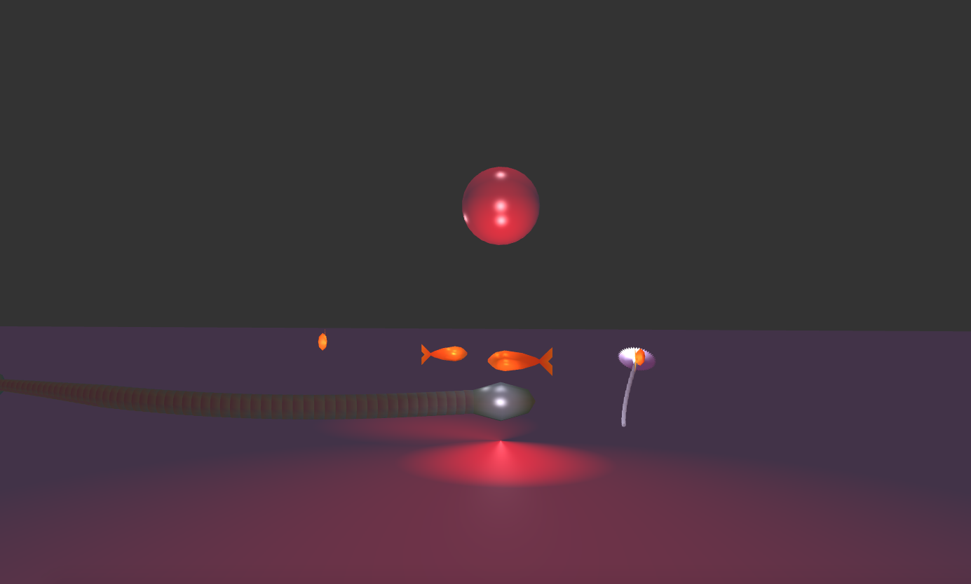

*Fully-lit scene*

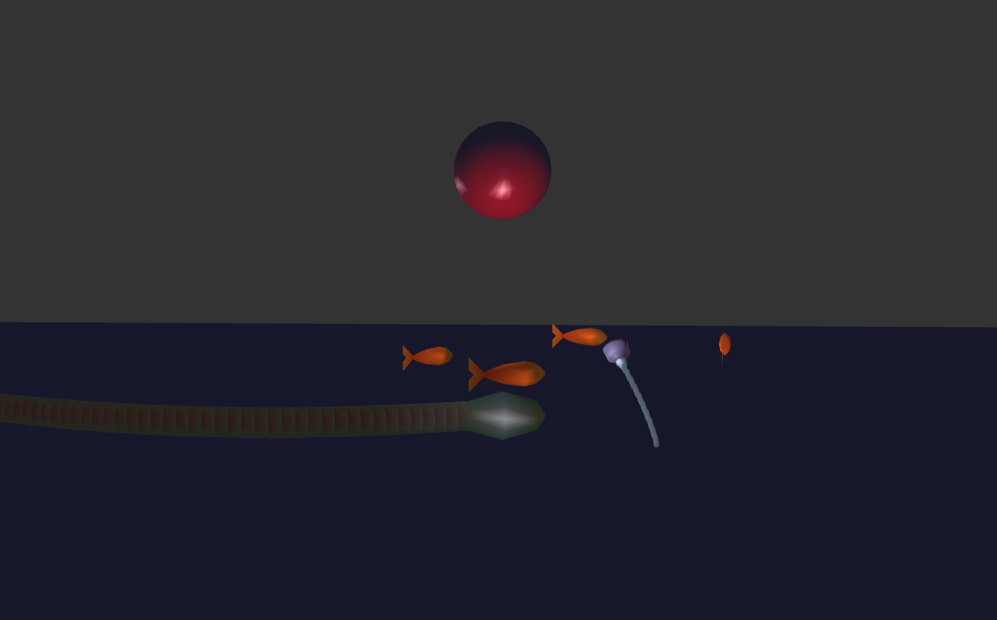

*Scene with only headlight and adjustable front light*

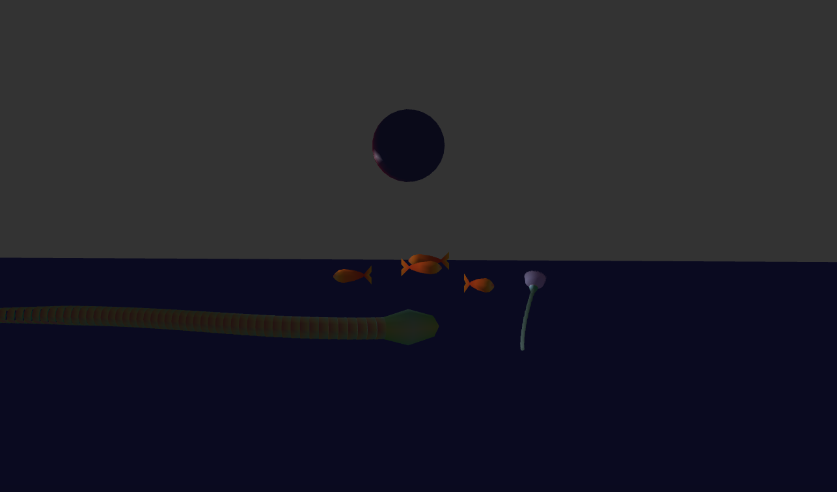

*Backlit scene*

*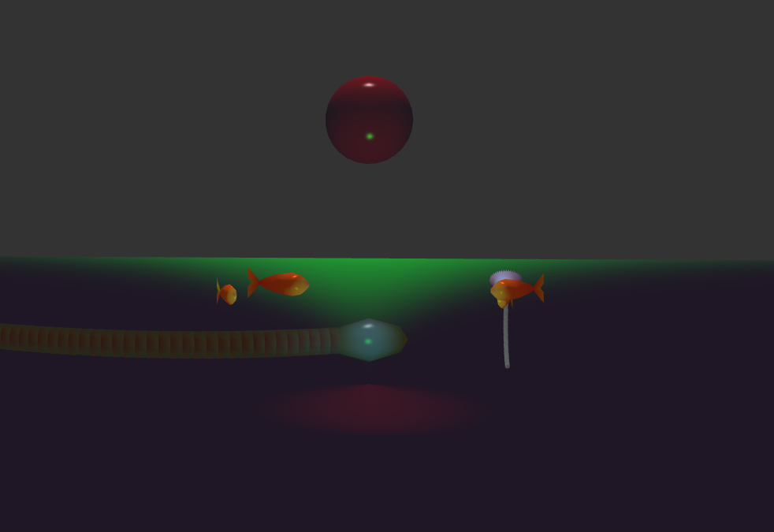Scene with adjustable front light’s color settings adjusted*

Scene Graph

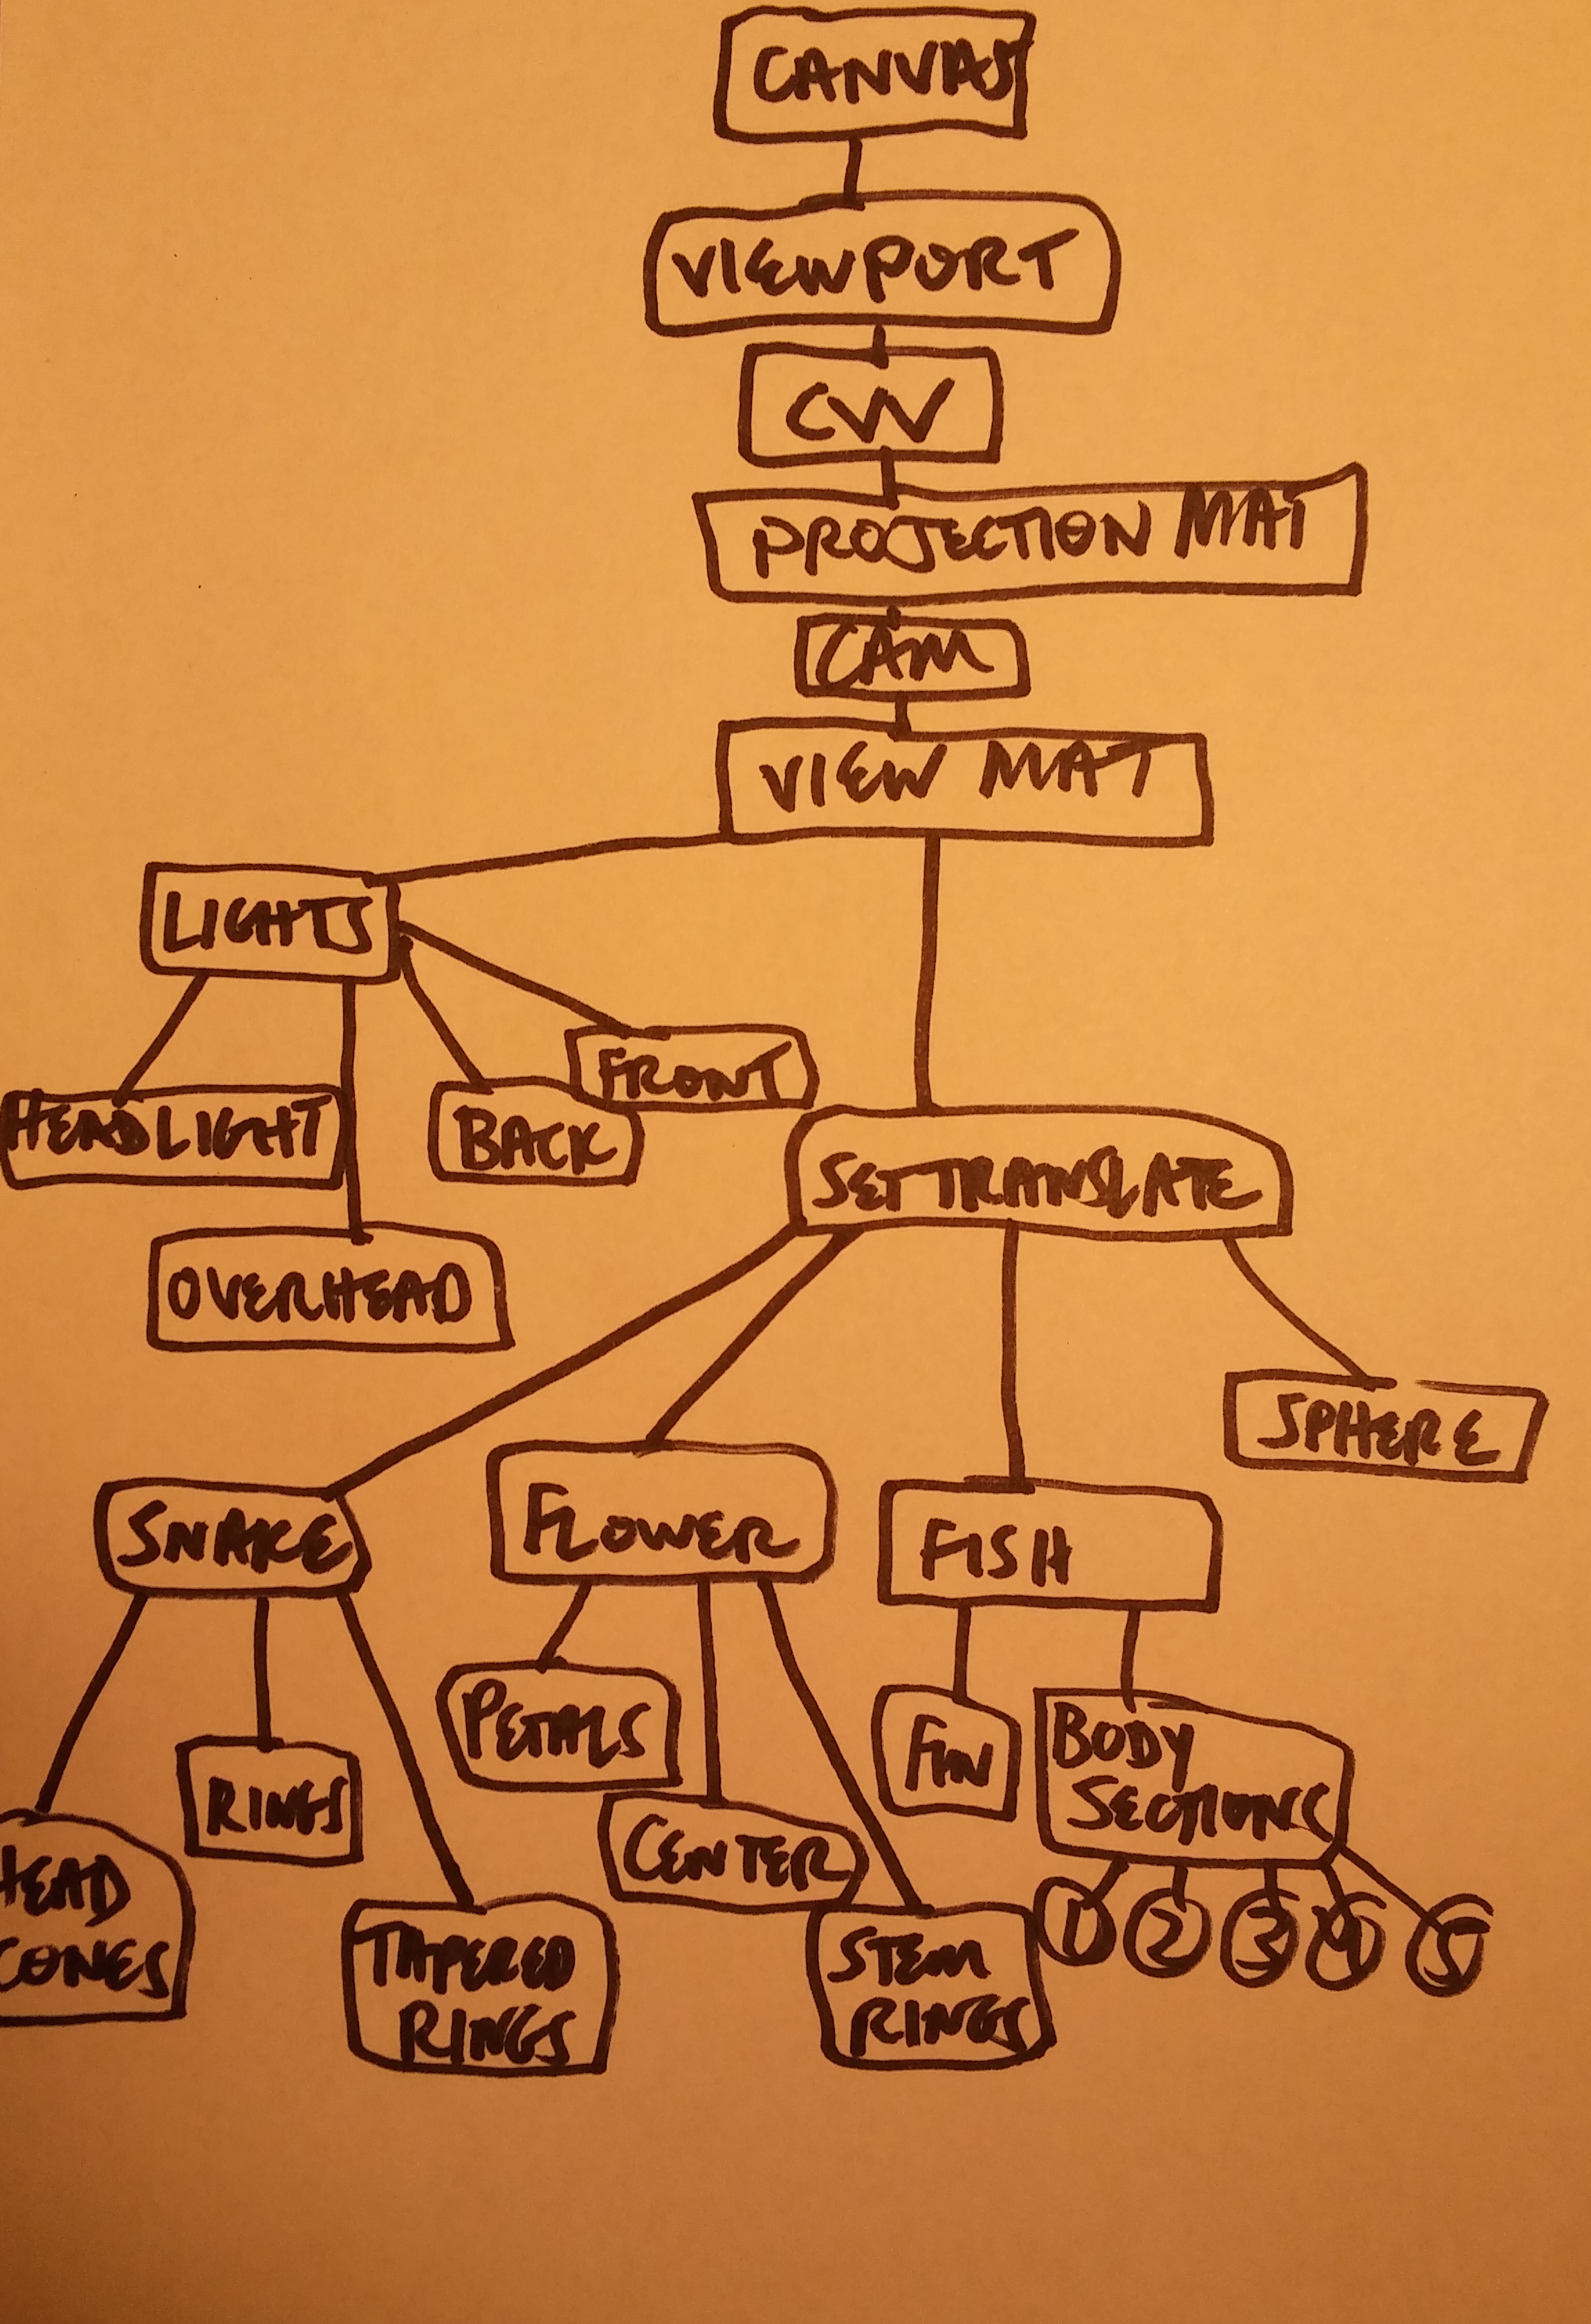

*I apologize that this is pretty sloppy or may not have all of what a scene graph is supposed to have. I honestly just realized this was a missing component from my earlier projects and I’m not sure I have a perfect handle on what it’s supposed to represent besides breaking down the objects on the screen.